1. **In a sample of 343 cases, if the mean score for a scale of functional impairment is 60 with a standard deviation of 10**
2. If you learn that the median of the functional impairment score is 56 what does this suggest?
3. What would knowing that the mode of the functional impairment score= 72 tell you?
4. Assuming the scores are normally distributed what percent of the cases are between 50 and 70?
5. Between what scores are 95% of the cases?
6. What is the variance for functional impairment?
7. What value represents a standard z-score of 1 and -1?
8. What is the z-score for a score of 68?

We want to know more about the population mean and error.

1. What is the standard error of the mean (SEM)?
2. What would the 95% confidence interval be for the population mean?

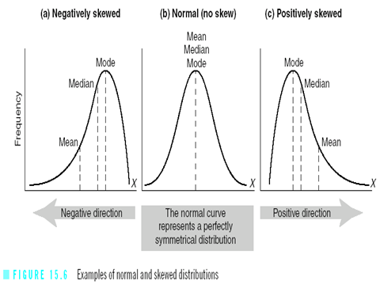

1. **The vitamin D levels for women aged 20-34 follow an approximately normal distribution with a mean of 35 nanograms per milliliter and a standard deviation of 15.**
2. If levels below 12 ng/mL indicate a vitamin D deficiency, estimate the percent of women who have levels below 12.
3. Visualize it--sketch the mean and z-score
4. Calculate the z-score
5. What percent are below 12 ng/mL?

Z = x – Mean

SD

B. Estimate the percent of women who have levels above 45 ng/mL .

1. Visualize it--sketch the mean and z-score
2. Calculate the z-score
3. What percent are above 45 ng/mL?
4. What vitamin D level coincides with 1 SD? 2SD?